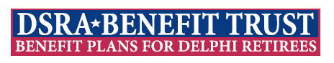
March 9, 2026

www.DSRABenefitTrust.net

Dear Fellow Retiree,

It is once again time to hold elections for our DSRA Benefit Trust Board of Directors (BoD). We have two board members, Stephen Duca and Sharon Delezenne, whose terms will expire. Both Stephen and Sharon have decided to seek reelection.

If you are interested in being a candidate in the upcoming election, we will issue more specific information in a few days. The following are a few “key dates” to be aware of:

March 11, 2026 - March 20, 2026 – Receive candidate nominations
March 21, 2026 – Official announcement of candidates
March 22,2026 to March 28, 2026 – Polls open for eligible voters
March 30, 2026 – Announce election results

Thank you for your consideration,
DSRA BT Election Committee

Lori Ostrander
Greg White

